**PRACTICAL – 3**

**AIM**: List at least 5 software development planning tools and prepare the detailed case study

of Risk Analysis & Management (i.e. Risk Identification, Risk Projection, Risk Refinement, Risk Mitigation.) on “WhatsApp” mobile application

**THEORY**

**Need of Project Planning:**

Software development is a sort of all new streams in world business, and there's next to no involvement in structure programming items.

Most programming items are customized to accommodate customer's necessities. The most significant is that the underlying technology changes and advances so generally and rapidly that experience of one element may not be connected to the other one.

All such business and ecological imperatives bring risk in software development; hence, it is fundamental to manage software projects efficiently

1. **TRELLO**

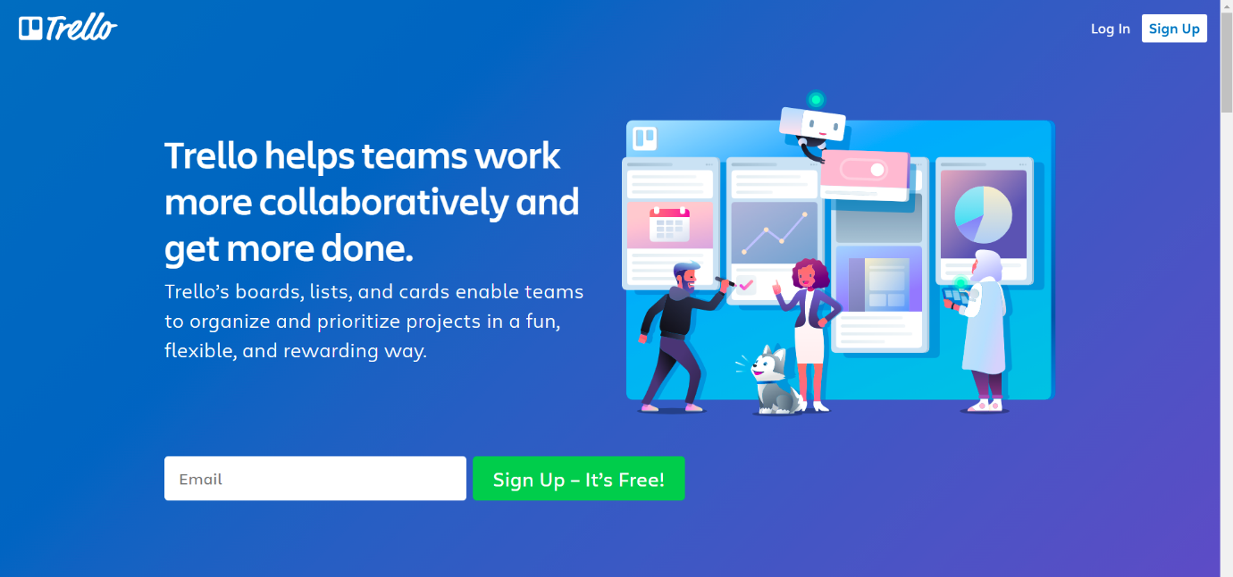

Trello allows you to create boards and fill them with different lists. I went for a simple Kanban-based board and created lists that correspond with statuses (in progress, to do etc.) Trello is a tool that would allow me to create more granular tasks but I’ve decided to use checklists that are built inside the cards to track smaller tasks. You can also add attachments to cards, making it easier to communicate new iterations or getting feedback. Adding due dates to particular cards is also handy when you want to plan a project.

1. **ASANA**



Asana is a popular tool for managing projects of various sizes, and while the free version comes with limited features, it seems to be perfectly suitable for smaller projects. The plan of your project can be displayed as a list, a board or a calendar (see below). The latter view is especially useful when planning milestones and deadlines. You can see how much time there actually is between different due dates. Keep in mind, however, that setting start dates for tasks is not available in the free plan.

1. **NIFTY**

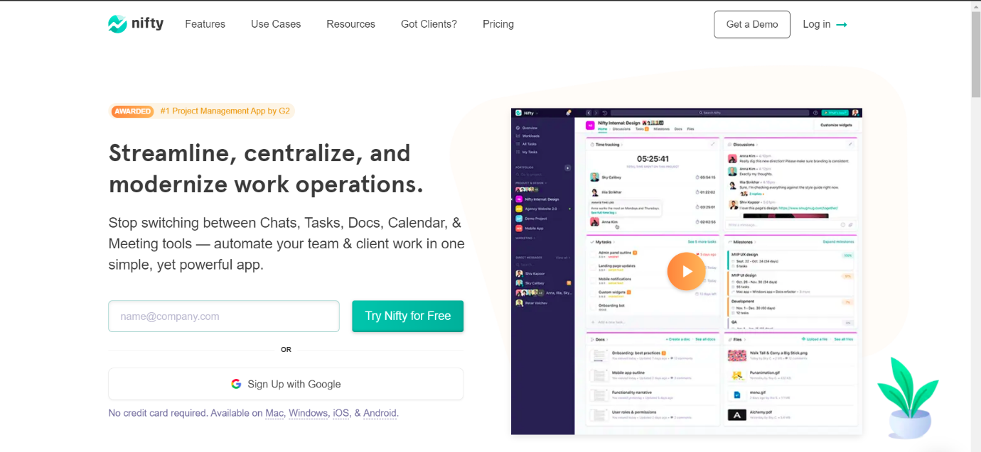

The creators of Nifty pride themselves on building an app that covers project management and team collaboration. The collaboration aspect is supported by the fact that a team chat is a part of this app. What about the project management part? You can plan your project starting with a list of tasks, or map your milestones on a Gantt chart.

1. **TEAMGANTT**

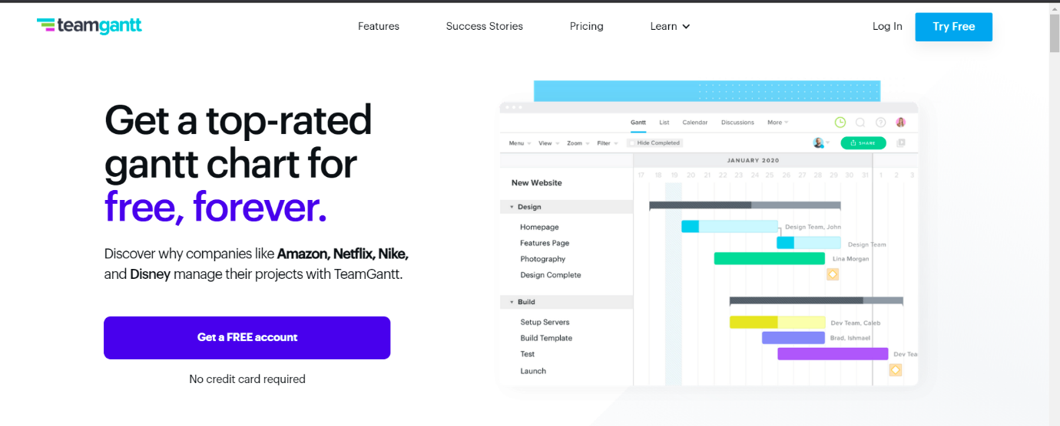

Out of the box you’ll notice that TeamGantt will not leave you hanging. The onboarding experience will help you tremendously, especially if you’re new to project planning or gantt charts in general. As the name of this software would suggest, creating Gantt charts is the core functionality here. The process of building and editing charts is very straightforward, you can also assign people to particular tasks

1. **NTASK**

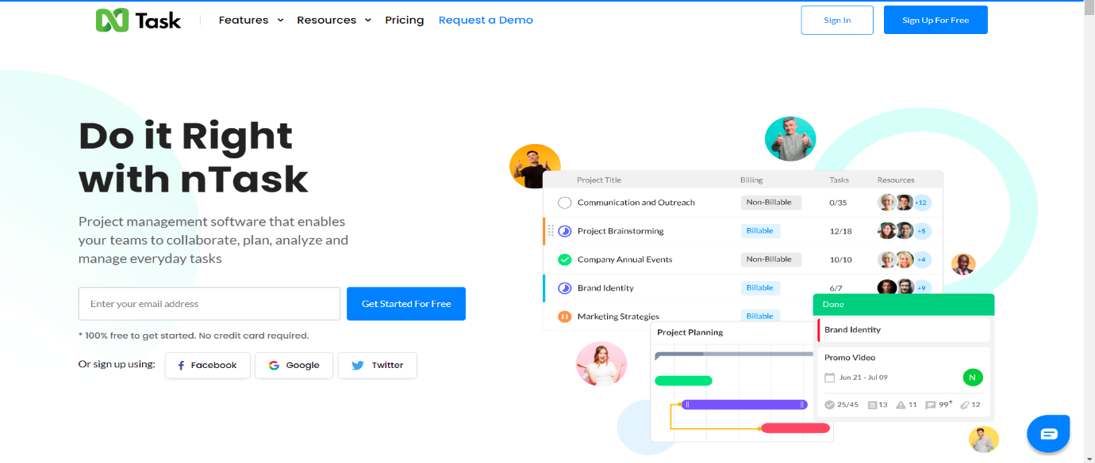

If you’re looking for a tool for planning and managing a series of projects, nTask could just be right for you. Of course, it will also be suitable for single project purposes. It’s just that nTask is really good at providing you with the big picture of all your ongoing projects. When it comes to planning a single project, you can create a list of tasks or a simple Gantt chart. The assignments can also be viewed as a grid.

**CASE STUDY ON “RISK ANALYSIS & MANAGEMENT IN WHATSAPP”**

**Overview:**

WhatsApp Messenger, or simply WhatsApp, is an American freeware, cross-platform centralized messaging and voice-over-IP service owned by Facebook, Inc. It allows users to send text messages and voice messages, make voice and video calls, and share images, documents, user locations, and other content. Since development of such great app includes high risk factors which we will analyse here.

Risk management is concerned with identifying risks and drawing up plans to minimise their effect on a project.

A risk is a probability that some adverse circumstance will occur.

• Project risks affect schedule or resources

• Product risks affect the quality or performance of the software being developed

• Business risks affect the organisation developing or procuring the software

A risk management process contains 4 major steps.

• Risk identification - Identify project, product and business risks

• Risk analysis - Assess the likelihood and consequences of these risks

• Risk planning - Draw up plans to avoid or minimise the effects of the risk

• Risk monitoring - Monitor the risks throughout the project.

**RISK ANALISIS AND MANAGEMENT ON WHATSAPP**

1. Risk Identification

From my perspective, in Risk Identification, there is some risk that can affect Whatsapp and that are:

* Business Impact: there is some similar kind of App. that are in Competition of Whatsapp.
* Technology to the limit: the Technology is latest or not.
* Development environment: If the Development Environment Changes the Application may get to the Failure.

2. Risk Projection

|  |  |  |  |
| --- | --- | --- | --- |
| RISK | CATEGORY | PROBABILITY | IMPACT |
| Other Applications that are similar to Whatsapp like Telegram,Signal | BU | 60% | 4 |
| Lack of Technology tools | DE | 40% | 2 |
| Application not meet expectations | TE | 20% | 1 |

3. Risk Refinement

We can use the risk Identification list that are made on the basis of the risk item checklist that is build on risk analysis questions. So further that question will be get sub question like for example we have risk in Lack of technology tools so there is some sub question like what tools and what is the cost? and risk impact is on level 2 so risk has to be solved.

4. Risk Mitigation

from the Risks that we have discussed above in in risk projection:

* Other Applications that are similar to Whatsapp like Telegram, Signal so we can Avoid this Risk for Risk Mitigation.
* Lack of Technology tools so we can Accept the Risk and find the best employee that can work on any environment.
* Application not meet expectations so for this Risk we can Reduce the Risk.

**CONCLUSION**

In this practical, we learned about different software development planning tools. Then we explored risk analysis and risk management. We performed case study for whatsapp on same topic.